Circuit Analysis (Lab5)

Experiment 6: Verification of Kirchoff’s Law

Name: Noor-ul-Ain

Date: 25 April’2026

Registration No: 2025-CE-83

Grade and Signature: ………………………

Procedure for KCL
- Connect the circuit as per the KCL diagram using resistors on the breadboard (node-based circuit).
- Switch ON the regulated power supply.
- Set the voltage (e.g., 5V).
- Measure currents I₁, I₂, I₃ using the digital multimeter.
- Verify that:
I1=I2+I3
- Repeat the experiment for different voltages (15V, 25V).
- Record all readings in the observation table.
Sl. No. | Voltage E | Current |  |  | I1 = I2 + I3
1 | 5 | 5.68 | 2.56 | 3.12 | 5.68=2.56+3.12
2 | 15 | 17.1 | 9.37 | 7.68 | 17.1=9.37+7.68
3 | 25 | 28.4 | 15.6 | 12.8 | 28.4=15.6+12.8

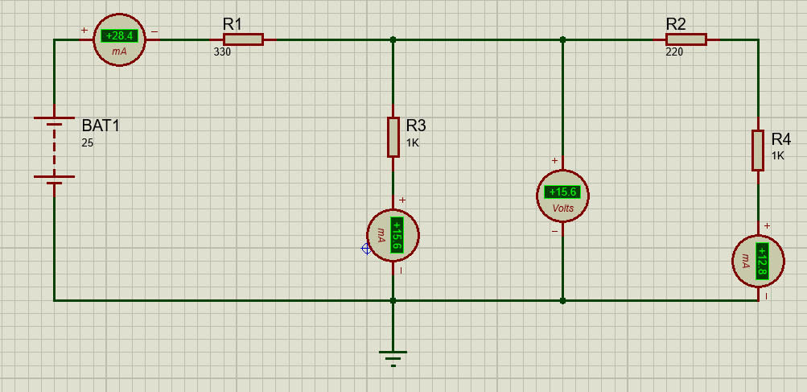

Procedure for KVL
- Connect the circuit as per KVL loop diagram (series resistors).
- Switch ON the regulated power supply.
- Set voltage (5V).
- Measure voltages across each resistor: V₁, V₂, V₃.
- Verify that:
E1=V1+V2+V3
- Repeat for different voltages (10V, 15V).
- Record observations.
Sl. No. | RPS | Voltage |  |  | E1 = V1 + V2+V3
1 | 5 | 1.06 | 0.71 | 3.23 | 5=1.06+0.71+3.23
2 | 10 | 2.13 | 1.42 | 6.46 | 10=2.13+1.42+6.46
3 | 15 | 3.19 | 2.13 | 9.68 | 15=3.19+2.13+9.68

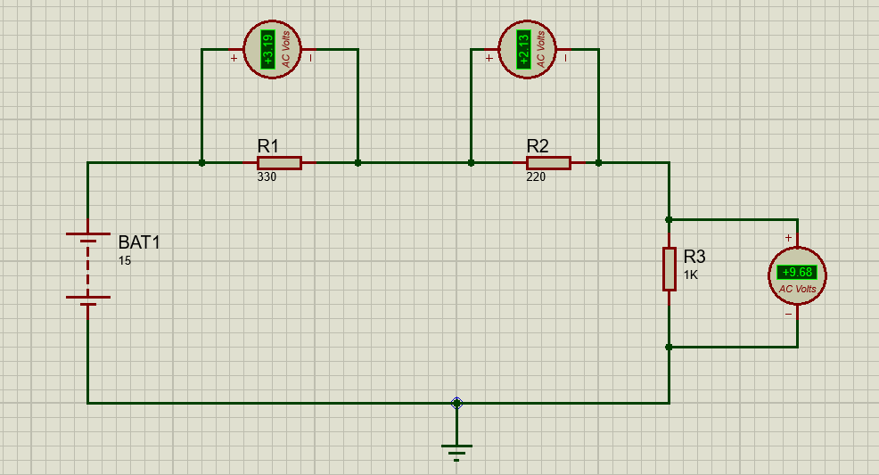

Result
Thus, Kirchhoff’s Current Law and Kirchhoff’s Voltage Law are verified, as the measured values satisfy:
- Current entering a node equals current leaving it.
- Sum of voltage drops equals applied voltage in a loop.

